1. Use Case Summary
This is a high-level overview of what the system enables each actor to do.
Actors and Their Use Cases
Actor | Use cases
patient | View Dashboard, View Profile, View Records, View Lab Results, Manage Appointments, View Insurance Status
Doctor/Lab-Tec | View Dashboard, Search Patients, View Patient Profile, View Lab Results, Manage Appointments
Admin
  Search Patient, Search Doctor, Create Account (Patient/Doctor), Forward Patient Records

Each use case represents a goal-driven interaction between the actor and the system.
2 use-case Diagram (textual UML Representation)
Actors:
-Patient
-Doctor/Lab-Tec
-Admin

Use-cases:
-View Dashboard
Includes Fetch Latest data
- View Profile
- View Records
- View Lab Results
Extends Download PDF Report
- Manage Appointments
IncludesSearch Patient
- View Insurance
Extends Update Insurance Info

- Search Patient
Extends Forward Patient Records
-View Patient profile
- Search Doctor
- Create Account
Includes Validate Input

Relationships:
Patient → View Dashboard, View Profile, View Records, View Lab Results, Manage Appointments, View Insurance
Doctor/Lab-Tech → View Dashboard, Search Patient, View Patient Profile, View Lab Results, Manage Appointments
Admin → Search Patient, Search Doctor, Create Account, Forward Records

Relationship Types in our Use Case Diagram

I. Association (↔)
Basic interaction between an actor and a use case. E.g
- Patient ↔ View Dashboard
- Doctor ↔ Search Patient
- Admin ↔ Create Account
These are direct interactions.

II. «include»
Used when one use case always includes another.
Base Use Case | Included Use Case | Why?
Create Account | Validate Input | Input must always be validated before account creation.
Manage Appointments | Search Patient | Doctors must search/select a patient before managing appointments.
View Dashboard | Fetch Latest Data | Dashboard always pulls latest diagnosis, labs, etc.

Notation: Dashed arrow with «include» pointing to the included use case.

«extend»
Used when a use case optionally extends another under certain conditions.
Base Use Case | Extending Use Case | When?
View Lab Results | Download PDF Report | If patient/doctor clicks “Download”
Search Patient | Forward Patient Records | If admin chooses to forward after search
View Insurance |  | If patient clicks “Edit”
  Update Insurance Info

Notation: Dashed arrow with «extend» pointing from the extending use case to the base.

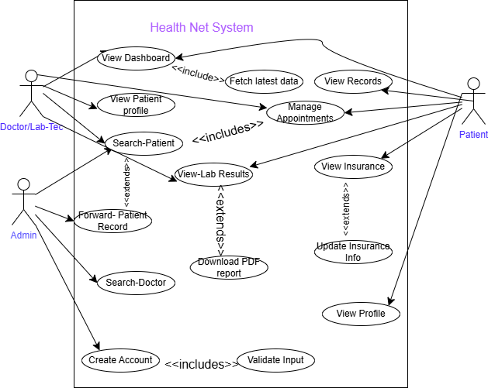

3. Informal Use Case Descriptions

Patient – View Dashboard
The patient logs in and sees a dashboard summarizing their latest diagnosis, upcoming appointments, current medications, and recent lab results.

Patient – View Records
The patient navigates to “My Records” to view past medical cases, including hospital name and date.

Doctor – Search Patient
The doctor logs in, enters a patient’s name or case ID, and retrieves their profile and medical history.

Admin – Create Account
The admin opens the “Create Account” tab, enters user details, and registers a new patient or doctor.

4. Formal Use Case Examples
Use Case: View Records (Patient)
Elements | Description
Actor | Patient
Goal | To view personal medical records including case ID, hospital, and date.
 | Patient must be logged in.
  Preconditions
Main Flow | 1. Patient logs in. 2. Navigates to “My Records”. 3. System displays records.
Alternative Flow | No records found → system displays “No records available.”
 | Patient views or downloads their records.
  Postconditions
Use Case: Search Patient (Doctor/Lab-Tech)
Elements | Description
Actor | Doctor/Lab-Tech
Goal | To locate a patient’s profile and medical records.
 | Actor must be authenticated.
  Preconditions
Main Flow | 1. Actor logs in. 2. Navigates to “Search Patient”.3. Enters search criteria4. System displays results.
Alternative Flow | No match found → system displays “No patient found.”
 | Doctor accesses patient profile and records.
  Postconditions
Use Case: Create Account (Admin)
Elements | Description
Actor
  Admin
Goal | To register a new patient or doctor.
 | Admin must be logged in.
  Preconditions
Main Flow | 1. Admin logs in2. Opens “Create Account”. 3. Enters user details. 4. System validates and stores data.
Alternative Flow | Duplicate detected → system prompts merge or alerts admin.
 | New user account is created.
  Postconditions

Tools that we used
https://app.diagrams.net
for drawing use-case digram
references that we used
1, https://creately.com/guides/use-case-diagram-tutorial
2, https://www.geeksforgeeks.org/system-design/use-case-diagram
3, https://www.softwaretestinghelp.com/use-case-diagram-tutorial
4, the ppt material that we were shared by our instructor Mrs. Nuniyat Kassie
Acronymes:
Association relation ship( )
Extended relationships(---<<extend>>---)
Include relationship(---<<include>>---)
Generalization inheritance(solid line with a hollow triangle arrowhead) but we don’t use in our use case

NB:
In our current healthcare management system, generalization is not strictly needed yet, because:
- our actors (Patient, Doctor/Lab-Tech, Admin) are distinct and not hierarchical.
- our use cases are modular and don’t have subtypes.
But if we later introduce Receptionist, Nurse, or Specialist Doctor, generalization would help clarify role inheritance.

